Product Inventory Management System
Ideation Phase
Empathize & Discover

Date | 05/03/2026
Team ID | SWTID-2026-2317
Project Name | Product Inventory Management
Maximum Marks | 4 Marks

Empathy Map Canvas
An Empathy Map is a simple and effective tool used to understand the behaviours, thoughts, needs, and challenges of users. It helps project teams visualize the user's experience and gain deeper insights into how users interact with a system.
The empathy map allows the team to analyze what users think, feel, say, and do while using a product or service. By understanding these aspects, developers and designers can build solutions that better address the actual problems faced by users.
This tool is especially useful during the problem analysis and solution design phase, as it helps teams focus on the user’s perspective rather than only technical aspects.
Creating an empathy map encourages team members to:
- Understand the real needs and expectations of users
- Identify user challenges and frustrations
- Recognize user goals and motivations
- Design solutions that improve the overall user experience
In the Product Inventory Management System, the empathy map helps the team understand the difficulties faced by small business owners, freelancers, and shop managers when managing their product inventory. This understanding helps in designing a system that is simple, secure, and efficient for managing product data.

Example
For example, a small business owner may:
- Think: "I need an easy way to track my product stock."
- Feel: Frustrated when inventory records are not updated properly.
- Say: "Managing inventory manually takes too much time."
- Do: Use spreadsheets or notebooks to track product details.
This insight helps the development team design a secure and user-friendly inventory management system that simplifies product tracking and management.
Example:
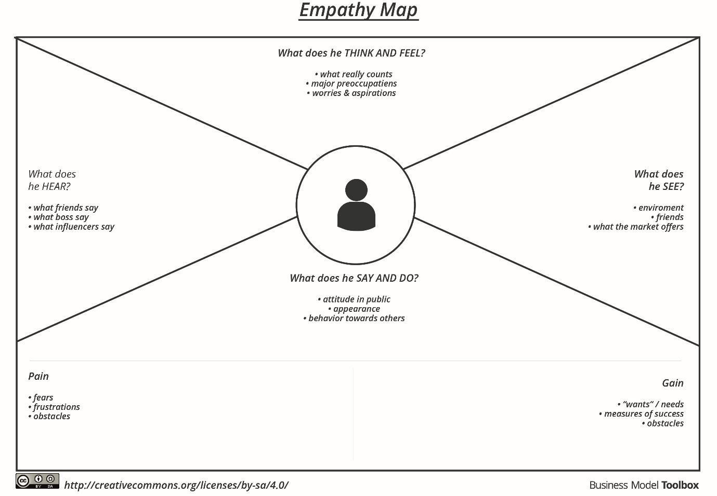
Reference: https://www.mural.co/templates/empathy-map-canvas

